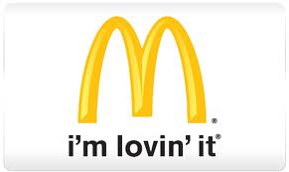  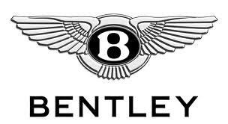

**Find the Country / Nationality / Name of Object / Purpose or Focus- 4 Points**

***1***

***2***

***3***

***5***

***4***

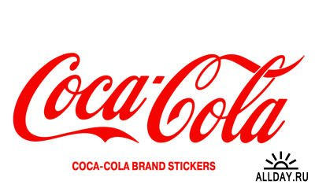 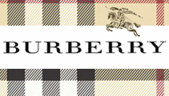

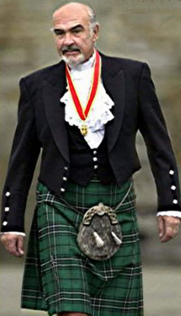 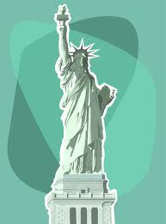 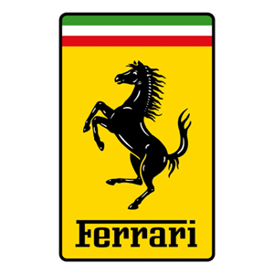

***8***

***7***

***6***

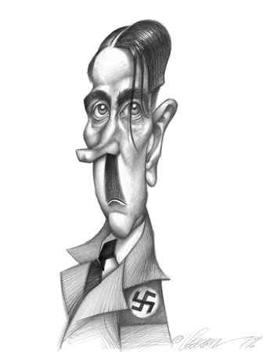**[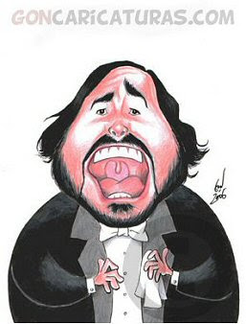](http://2.bp.blogspot.com/_Mi7AIQ22soI/SPT6YMifP3I/AAAAAAAACfw/1cXdFXSEnEY/s1600-h/pavarotti_caricature.jpg)**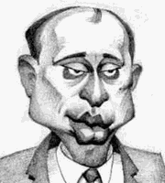

***9***

***11***

***10***

***14***

***13***

***12***

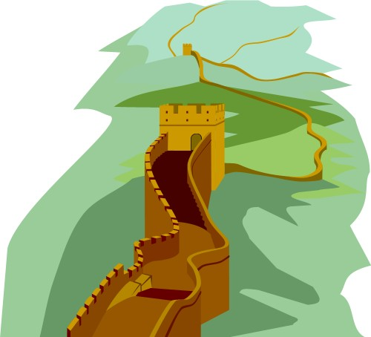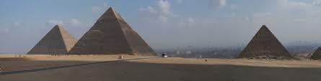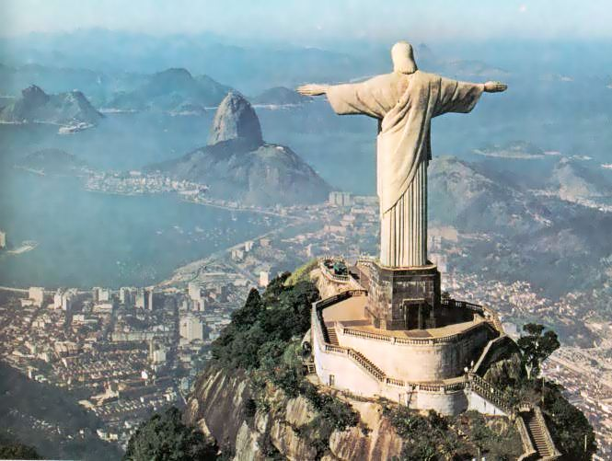

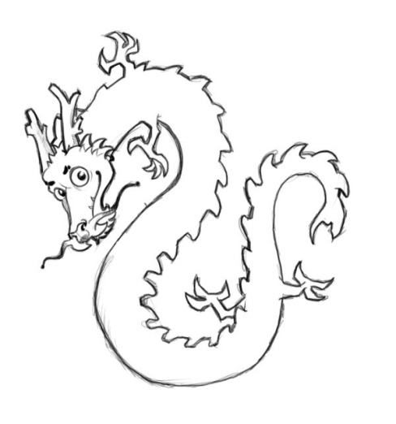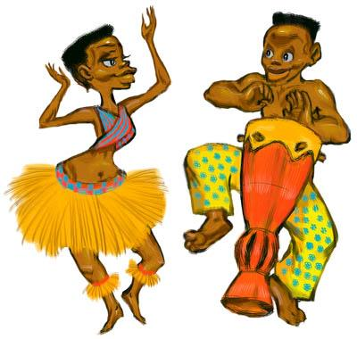

***17***

***16***

***15***

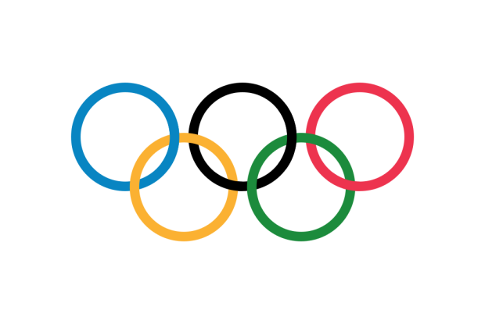

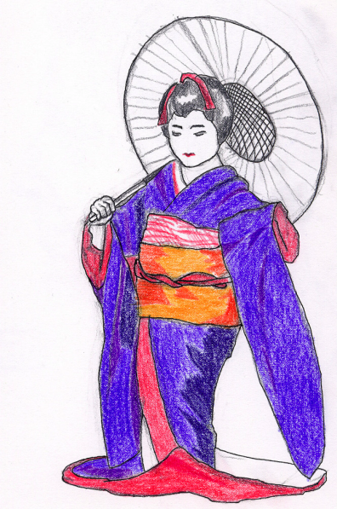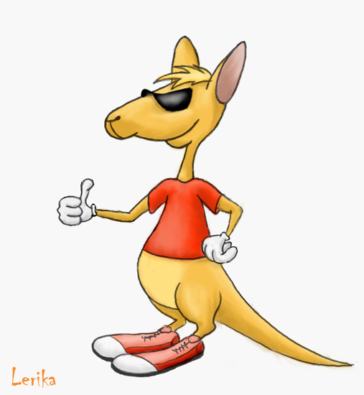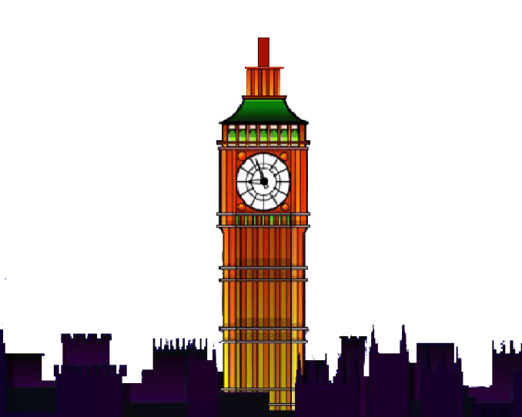

***20***

***19***

***18***

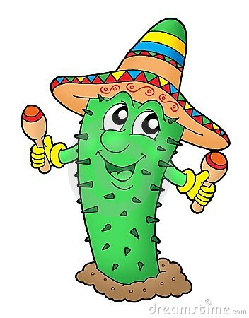

***23***

***22***

***21***

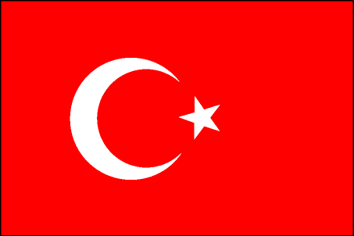

1. The USA / American McDonalds / food
2. England / English Bentley / cars
3. France / French Chanel / clothing
4. The USA / American coca cola / drink
5. England / English Burberry / clothes
6. Scotland / Scottish kilt / Scottish
7. The USA / American statue of liberty / landmark
8. Italy / Italian Ferrari / cars
9. Germany / German Hitler / political leader
10. Italy / Italian pavorette / singer
11. Russia / Russian Putin / president
12. Brazil / Brazilian statue of god / landmark
13. Egypt / Egyptian pyramid / landmark
14. China / Chinese wall of china / landmark tradition
15. Africa / African African dance / tradition
16. China / Chinese dragon / symbol
17. Greece / Greek Olympics / sporting event
18. Japan / Japanese geisha / tradition
19. France / French Eiffel tower / landmark building
20. England / English big Ben / landmark clock
21. Mexico / Mexican cactus / plant
22. Australia / Australian kangaroo / Australia
23. Turkey / Turkey flag / country representation

Students in either pairs or groups should guess or write (4 points)

* Country
* Nationality
* Name of item
* Focus / purpose